Contents

MAMS DATASET 1

SENTIHOOD 8

YASO 11

SEMEVAL 16

DOTSA 20

# MAMS DATASET

RESULTS LSTM TERMS BASED MAMS DATASET

1. MAMS(ACSA)

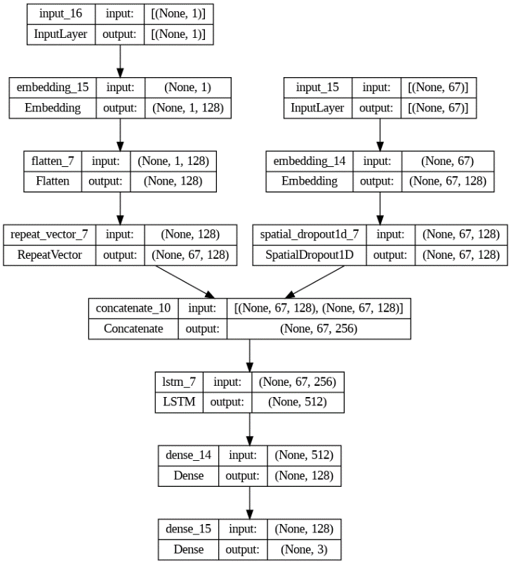Model summary:  
  
## LSTM with Aspect Embedding:

learning_rate_reduction = ReduceLROnPlateau(monitor='val_accuracy',

                                                    patience = 2,

                                                    verbose=1,

                                                    factor=0.1,

                                                    min_lr=0.000001)

from tensorflow import keras

opt = keras.optimizers.Adam(learning_rate=0.01)

ae_lstm_model.compile(loss='sparse_categorical_crossentropy', metrics=['accuracy'], optimizer=opt)

history =  ae_lstm_model.fit(x = train_data, y = y_train, validation_data = (val_data, y_val), batch_size=16, epochs=20, callbacks = [learning_rate_reduction])

Evaluate on test data

42/42 [==============================] - 0s 10ms/step - loss: 0.9782 - accuracy: 0.5614

test loss, test acc: [0.9782399535179138, 0.561377227306366]

Accuracy of the model is - 56.1377227306366 %

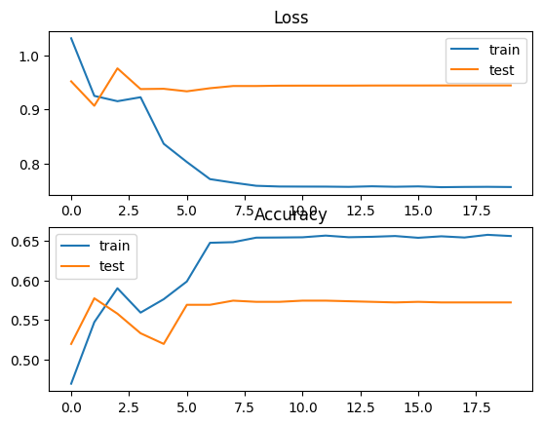

Attention-based LSTM (AT-LSTM)

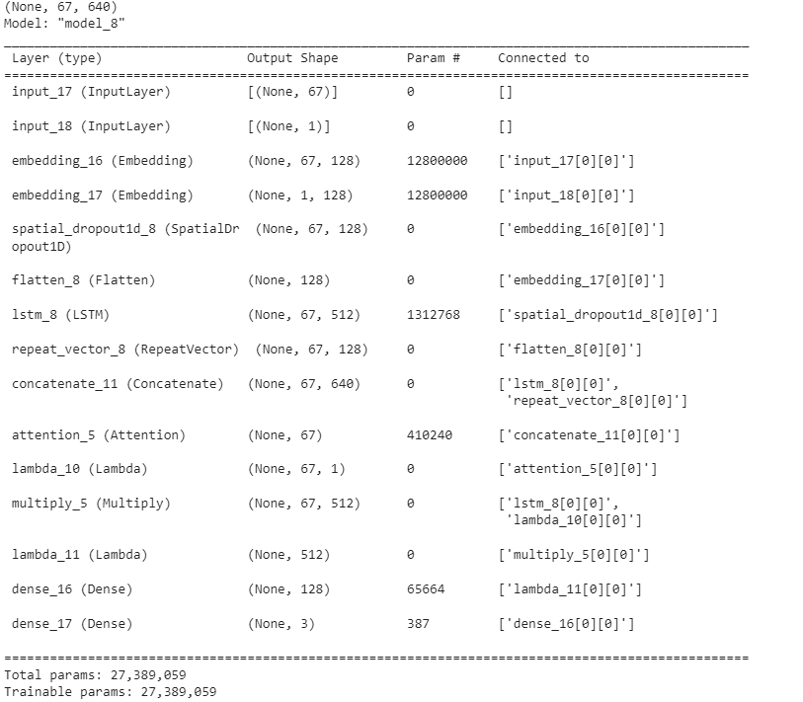

learning_rate_reduction = ReduceLROnPlateau(monitor='val_accuracy',

                                                    patience = 1,

                                                    verbose=1,

                                                    factor=0.1,

                                                    min_lr=0.000001)

opt = keras.optimizers.Adam(learning_rate=0.01)

at_lstm_model.compile(loss='sparse_categorical_crossentropy', metrics=['accuracy'], optimizer=opt)

at_lstm_model .fit(x = train_data, y = y_train, validation_data = (val_data, y_val), batch_size=32, epochs=20, callbacks = [learning_rate_reduction])



Evaluate on test data

42/42 [==============================] - 0s 10ms/step - loss: 0.9627 - accuracy: 0.5988

test loss, test acc: [0.9626598954200745, 0.598802387714386]

Accuracy of the model is - 59.8802387714386 %

Attention-based LSTM with Aspect Embedding (ATAE-LSTM)

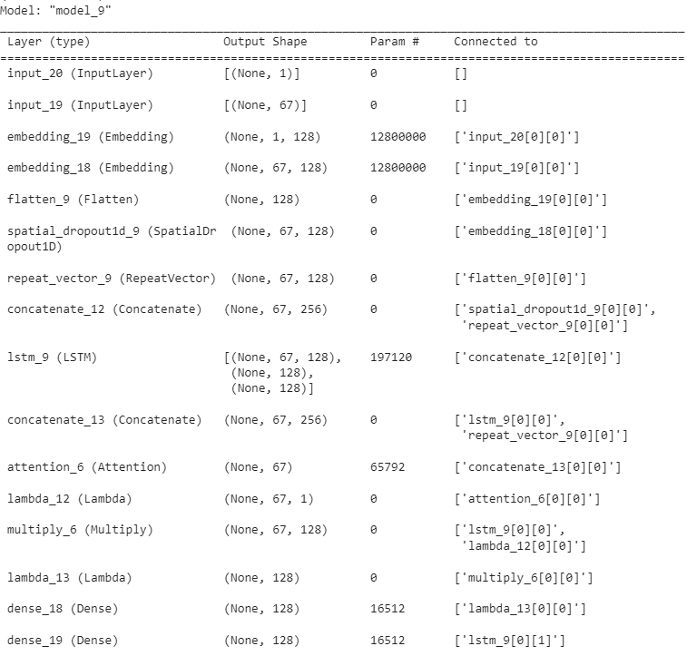

learning_rate_reduction = ReduceLROnPlateau(monitor='val_accuracy',

                                                    patience = 2,

                                                    verbose=1,

                                                    factor=0.1,

                                                    min_lr=0.000001)

atae_lstm_model.compile(loss='sparse_categorical_crossentropy', metrics=['accuracy'], optimizer='adam')

atae_lstm_model .fit(x = train_data, y = y_train, validation_data = (val_data, y_val), batch_size=32, epochs=20, callbacks = [learning_rate_reduction])



Evaluate on test data

42/42 [==============================] - 0s 6ms/step - loss: 1.6163 - accuracy: 0.5936

test loss, test acc: [1.616341233253479, 0.59356290102005]

Accuracy of the model is - 59.356290102005005 %

# SENTIHOOD

RESULTS LSTM TERM BASED SENTIHOOD DATASET

NOTE: MODEL SUMMARY SIMILAR TO THE MAMS DATASET

1. ## LSTM with Aspect Embedding:

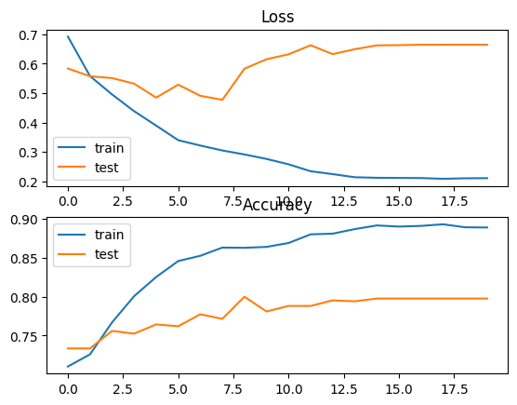

Evaluate on test data

53/53 [==============================] - 1s 10ms/step - loss: 0.6288 - accuracy: 0.7820

test loss, test acc: [0.6287934184074402, 0.7820131182670593]

Accuracy of the model is - 78.20131182670593 %

Attention-based LSTM (AT-LSTM)



Evaluate on test data

53/53 [==============================] - 1s 11ms/step - loss: 0.5888 - accuracy: 0.7248

test loss, test acc: [0.5888075232505798, 0.7248362302780151]

Accuracy of the model is - 72.48362302780151 %

Attention-based LSTM with Aspect Embedding (ATAE-LSTM



Evaluate on test data

53/53 [==============================] - 0s 6ms/step - loss: 1.1513 - accuracy: 0.7802

test loss, test acc: [1.1512519121170044, 0.7802263498306274]

Accuracy of the model is - 78.02263498306274 %

# YASO

RESULTS LSTM TERMS BASED YASO DATASET

## LSTM with Aspect Embedding:

learning_rate_reduction = ReduceLROnPlateau(monitor='val_accuracy',

                                                    patience = 2,

                                                    verbose=1,

                                                    factor=0.1,

                                                    min_lr=0.000001)

from tensorflow import keras

opt = keras.optimizers.Adam(learning_rate=0.01)

ae_lstm_model.compile(loss='sparse_categorical_crossentropy', metrics=['accuracy'], optimizer=opt)

history =  ae_lstm_model.fit(x = train_data, y = y_train,validation_data = (val_data, y_val), batch_size=16, epochs=20, callbacks = [learning_rate_reduction])

Evaluate on test data

10/10 [==============================] - 0s 9ms/step - loss: 1.0049 - accuracy: 0.6334

test loss, test acc: [1.00486421585083, 0.6334404945373535]

Accuracy of the model is - 63.34404945373535 %

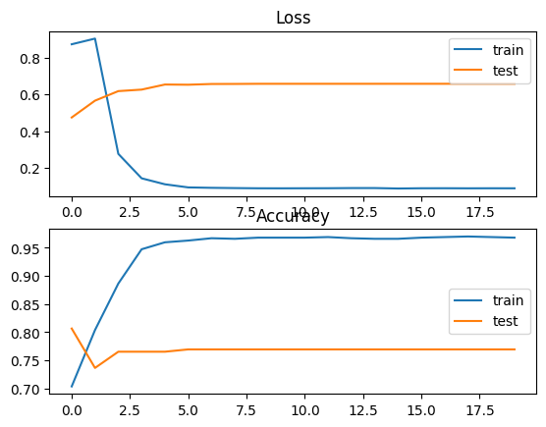

Attention-based LSTM (AT-LSTM)

learning_rate_reduction = ReduceLROnPlateau(monitor='val_accuracy',

                                                    patience = 2,

                                                    verbose=1,

                                                    factor=0.1,

                                                    min_lr=0.000001)

opt = keras.optimizers.Adam(learning_rate=0.01)

at_lstm_model.compile(loss='sparse_categorical_crossentropy', metrics=['accuracy'], optimizer=opt)

at_lstm_model .fit(x = train_data, y = y_train,validation_data = (val_data, y_val), batch_size=16, epochs=20, callbacks = [learning_rate_reduction])

Evaluate on test data

10/10 [==============================] - 0s 9ms/step - loss: 0.5399 - accuracy: 0.7749

test loss, test acc: [0.5399052500724792, 0.7749196290969849]

Accuracy of the model is - 77.49196290969849 %



Attention-based LSTM with Aspect Embedding (ATAE-LSTM

learning_rate_reduction = ReduceLROnPlateau(monitor='val_accuracy',

                                                    patience = 2,

                                                    verbose=1,

                                                    factor=0.1,

                                                    min_lr=0.000001)

atae_lstm_model.compile(loss='sparse_categorical_crossentropy', metrics=['accuracy'], optimizer='adam')

atae_lstm_model .fit(x = train_data, y = y_train,validation_data = (val_data, y_val), batch_size=16, epochs=20, callbacks = [learning_rate_reduction])

Evaluate on test data

10/10 [==============================] - 0s 7ms/step - loss: 1.7666 - accuracy: 0.8167

test loss, test acc: [1.766563057899475, 0.8167202472686768]

Accuracy of the model is - 81.67202472686768 %



# SEMEVAL

RESULTS LSTM TERMS BASED semEval Restaurant DATASET

## LSTM with Aspect Embedding:

learning_rate_reduction = ReduceLROnPlateau(monitor='val_accuracy',

                                                    patience = 2,

                                                    verbose=1,

                                                    factor=0.1,

                                                    min_lr=0.000001)

from tensorflow import keras

opt = keras.optimizers.Adam(learning_rate=0.01)

ae_lstm_model.compile(loss='sparse_categorical_crossentropy', metrics=['accuracy'], optimizer=opt)

history =  ae_lstm_model.fit(x = train_data, y = y_train, validation_data = (val_data, y_val), batch_size=16, epochs=20, callbacks = [learning_rate_reduction])

Evaluate on test data

21/21 [==============================] - 0s 8ms/step - loss: 1.5678 - accuracy: 0.6354

test loss, test acc: [1.5677930116653442, 0.6353846192359924]

Accuracy of the model is - 63.53846192359924 %

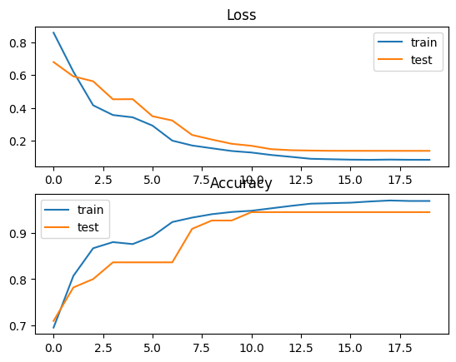

Attention-based LSTM (AT-LSTM)

learning_rate_reduction = ReduceLROnPlateau(monitor='val_accuracy',

                                                    patience = 2,

                                                    verbose=1,

                                                    factor=0.1,

                                                    min_lr=0.000001)

opt = keras.optimizers.Adam(learning_rate=0.01)

at_lstm_model.compile(loss='sparse_categorical_crossentropy', metrics=['accuracy'], optimizer=opt)

at_lstm_model .fit(x = train_data, y = y_train, validation_data = (val_data, y_val), batch_size=16, epochs=20, callbacks = [learning_rate_reduction])

Evaluate on test data

21/21 [==============================] - 0s 8ms/step - loss: 0.7044 - accuracy: 0.7431

test loss, test acc: [0.7044448852539062, 0.7430769205093384]

Accuracy of the model is - 74.30769205093384 %



Attention-based LSTM with Aspect Embedding (ATAE-LSTM

learning_rate_reduction = ReduceLROnPlateau(monitor='val_accuracy',

                                                    patience = 2,

                                                    verbose=1,

                                                    factor=0.1,

                                                    min_lr=0.000001)

atae_lstm_model.compile(loss='sparse_categorical_crossentropy', metrics=['accuracy'], optimizer='adam')

atae_lstm_model .fit(x = train_data, y = y_train, validation_data = (val_data, y_val), batch_size=16, epochs=20, callbacks = [learning_rate_reduction])

Evaluate on test data

21/21 [==============================] - 0s 5ms/step - loss: 1.1538 - accuracy: 0.7815

test loss, test acc: [1.1538214683532715, 0.7815384864807129]

Accuracy of the model is - 78.15384864807129 %



# DOTSA

RESULTS LSTM TERMS BASED DOTSA BOOKS DATASET

## LSTM with Aspect Embedding:

learning_rate_reduction = ReduceLROnPlateau(monitor='val_accuracy',

                                                    patience = 2,

                                                    verbose=1,

                                                    factor=0.1,

                                                    min_lr=0.000001)

from tensorflow import keras

opt = keras.optimizers.Adam(learning_rate=0.01)

ae_lstm_model.compile(loss='sparse_categorical_crossentropy', metrics=['accuracy'], optimizer=opt)

history =  ae_lstm_model.fit(x = train_data, y = y_train, validation_data = (val_data, y_val), batch_size=16, epochs=20, callbacks = [learning_rate_reduction])

Evaluate on test data

12/12 [==============================] - 1s 85ms/step - loss: 0.9165 - accuracy: 0.6576

test loss, test acc: [0.9164766073226929, 0.657608687877655]

Accuracy of the model is - 65.7608687877655 %

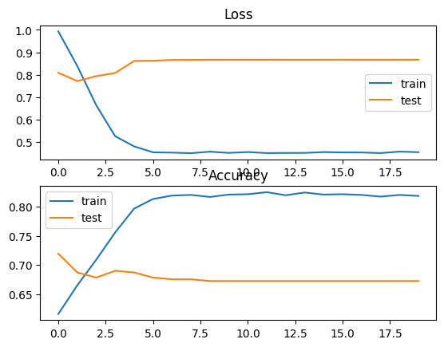

Attention-based LSTM (AT-LSTM)

learning_rate_reduction = ReduceLROnPlateau(monitor='val_accuracy',

                                                    patience = 2,

                                                    verbose=1,

                                                    factor=0.1,

                                                    min_lr=0.000001)

atae_lstm_model.compile(loss='sparse_categorical_crossentropy', metrics=['accuracy'], optimizer='adam')

atae_lstm_model .fit(x = train_data, y = y_train, validation_data = (val_data, y_val), batch_size=16, epochs=20, callbacks = [learning_rate_reduction])

Evaluate on test data

12/12 [==============================] - 0s 25ms/step - loss: 1.5554 - accuracy: 0.6821

test loss, test acc: [1.5554001331329346, 0.6820651888847351]

Accuracy of the model is - 68.20651888847351 %



Attention-based LSTM with Aspect Embedding (ATAE-LSTM

learning_rate_reduction = ReduceLROnPlateau(monitor='val_accuracy',

                                                    patience = 2,

                                                    verbose=1,

                                                    factor=0.1,

                                                    min_lr=0.000001)

atae_lstm_model.compile(loss='sparse_categorical_crossentropy', metrics=['accuracy'], optimizer='adam')

atae_lstm_model .fit(x = train_data, y = y_train, validation_data = (val_data, y_val), batch_size=16, epochs=20, callbacks = [learning_rate_reduction])

Evaluate on test data

21/21 [==============================] - 0s 5ms/step - loss: 1.1538 - accuracy: 0.7815

test loss, test acc: [1.1538214683532715, 0.7815384864807129]

Accuracy of the model is - 78.15384864807129 %



RESULTS LSTM TERMS BASED DOTSA CLOTHING DATASET

## LSTM with Aspect Embedding:

learning_rate_reduction = ReduceLROnPlateau(monitor='val_accuracy',

                                                    patience = 2,

                                                    verbose=1,

                                                    factor=0.1,

                                                    min_lr=0.000001)

from tensorflow import keras

opt = keras.optimizers.Adam(learning_rate=0.01)

ae_lstm_model.compile(loss='sparse_categorical_crossentropy', metrics=['accuracy'], optimizer=opt)

history =  ae_lstm_model.fit(x = train_data, y = y_train, validation_data = (val_data, y_val), batch_size=16, epochs=20, callbacks = [learning_rate_reduction])

Evaluate on test data

7/7 [==============================] - 0s 39ms/step - loss: 1.1551 - accuracy: 0.5918

test loss, test acc: [1.1551134586334229, 0.5918367505073547]

Accuracy of the model is - 59.183675050735474 %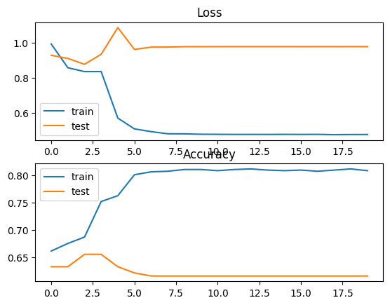

Attention-based LSTM (AT-LSTM)

learning_rate_reduction = ReduceLROnPlateau(monitor='val_accuracy',

                                                    patience = 2,

                                                    verbose=1,

                                                    factor=0.1,

                                                    min_lr=0.000001)

atae_lstm_model.compile(loss='sparse_categorical_crossentropy', metrics=['accuracy'], optimizer='adam')

atae_lstm_model .fit(x = train_data, y = y_train, validation_data = (val_data, y_val), batch_size=16, epochs=20, callbacks = [learning_rate_reduction])

Evaluate on test data

7/7 [==============================] - 0s 30ms/step - loss: 0.9851 - accuracy: 0.6173

test loss, test acc: [0.9851132035255432, 0.6173469424247742]

Accuracy of the model is - 61.73469424247742 %



Attention-based LSTM with Aspect Embedding (ATAE-LSTM

learning_rate_reduction = ReduceLROnPlateau(monitor='val_accuracy',

                                                    patience = 2,

                                                    verbose=1,

                                                    factor=0.1,

                                                    min_lr=0.000001)

atae_lstm_model.compile(loss='sparse_categorical_crossentropy', metrics=['accuracy'], optimizer='adam')

atae_lstm_model .fit(x = train_data, y = y_train, validation_data = (val_data, y_val), batch_size=16, epochs=20, callbacks = [learning_rate_reduction])

Evaluate on test data

7/7 [==============================] - 0s 21ms/step - loss: 2.0351 - accuracy: 0.6735

test loss, test acc: [2.0351204872131348, 0.6734693646430969]

Accuracy of the model is - 67.34693646430969 %



RESULTS LSTM TERMS BASED DOTSA HOTELS DATASET

## LSTM with Aspect Embedding:

learning_rate_reduction = ReduceLROnPlateau(monitor='val_accuracy',

                                                    patience = 2,

                                                    verbose=1,

                                                    factor=0.1,

                                                    min_lr=0.000001)

from tensorflow import keras

opt = keras.optimizers.Adam(learning_rate=0.01)

ae_lstm_model.compile(loss='sparse_categorical_crossentropy', metrics=['accuracy'], optimizer=opt)

history =  ae_lstm_model.fit(x = train_data, y = y_train, validation_data = (val_data, y_val), batch_size=16, epochs=20, callbacks = [learning_rate_reduction])

Evaluate on test data

18/18 [==============================] - 1s 36ms/step - loss: 0.5805 - accuracy: 0.8579

test loss, test acc: [0.5804994106292725, 0.8579235076904297]

Accuracy of the model is - 85.79235076904297 %

CodeText

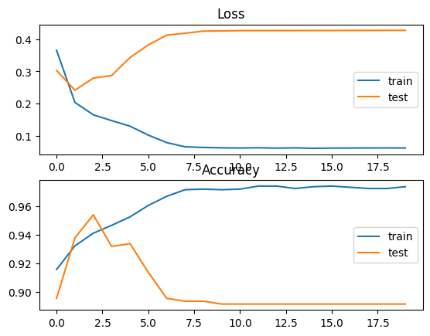

Attention-based LSTM (AT-LSTM)

learning_rate_reduction = ReduceLROnPlateau(monitor='val_accuracy',

                                                    patience = 2,

                                                    verbose=1,

                                                    factor=0.1,

                                                    min_lr=0.000001)

atae_lstm_model.compile(loss='sparse_categorical_crossentropy', metrics=['accuracy'], optimizer='adam')

atae_lstm_model .fit(x = train_data, y = y_train, validation_data = (val_data, y_val), batch_size=16, epochs=20, callbacks = [learning_rate_reduction])

Evaluate on test data

18/18 [==============================] - 1s 37ms/step - loss: 0.4050 - accuracy: 0.8925

test loss, test acc: [0.4050041139125824, 0.8925318717956543]

Accuracy of the model is - 89.25318717956543 %



Attention-based LSTM with Aspect Embedding (ATAE-LSTM

learning_rate_reduction = ReduceLROnPlateau(monitor='val_accuracy',

                                                    patience = 2,

                                                    verbose=1,

                                                    factor=0.1,

                                                    min_lr=0.000001)

atae_lstm_model.compile(loss='sparse_categorical_crossentropy', metrics=['accuracy'], optimizer='adam')

atae_lstm_model .fit(x = train_data, y = y_train, validation_data = (val_data, y_val), batch_size=16, epochs=20, callbacks = [learning_rate_reduction])

Evaluate on test data

18/18 [==============================] - 0s 18ms/step - loss: 1.1519 - accuracy: 0.8944

test loss, test acc: [1.151892066001892, 0.8943533897399902]

Accuracy of the model is - 89.43533897399902 %



RESULTS LSTM TERMS BASED DOTSA Restaurant DATASET

## LSTM with Aspect Embedding:

learning_rate_reduction = ReduceLROnPlateau(monitor='val_accuracy',

                                                    patience = 2,

                                                    verbose=1,

                                                    factor=0.1,

                                                    min_lr=0.000001)

from tensorflow import keras

opt = keras.optimizers.Adam(learning_rate=0.01)

ae_lstm_model.compile(loss='sparse_categorical_crossentropy', metrics=['accuracy'], optimizer=opt)

history =  ae_lstm_model.fit(x = train_data, y = y_train, validation_data = (val_data, y_val), batch_size=16, epochs=20, callbacks = [learning_rate_reduction])

Evaluate on test data

22/22 [==============================] - 1s 53ms/step - loss: 0.8087 - accuracy: 0.6569

test loss, test acc: [0.8086747527122498, 0.6568915247917175]

Accuracy of the model is - 65.68915247917175 %

CodeText

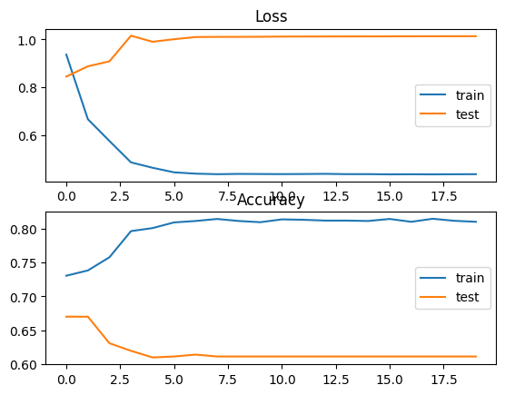

Attention-based LSTM (AT-LSTM)

learning_rate_reduction = ReduceLROnPlateau(monitor='val_accuracy',

                                                    patience = 2,

                                                    verbose=1,

                                                    factor=0.1,

                                                    min_lr=0.000001)

atae_lstm_model.compile(loss='sparse_categorical_crossentropy', metrics=['accuracy'], optimizer='adam')

atae_lstm_model .fit(x = train_data, y = y_train, validation_data = (val_data, y_val), batch_size=16, epochs=20, callbacks = [learning_rate_reduction])

Evaluate on test data

22/22 [==============================] - 1s 55ms/step - loss: 0.7220 - accuracy: 0.7537

test loss, test acc: [0.7219899296760559, 0.7536656856536865]

Accuracy of the model is - 75.36656856536865 %

CodeText



Attention-based LSTM with Aspect Embedding (ATAE-LSTM

learning_rate_reduction = ReduceLROnPlateau(monitor='val_accuracy',

                                                    patience = 2,

                                                    verbose=1,

                                                    factor=0.1,

                                                    min_lr=0.000001)

atae_lstm_model.compile(loss='sparse_categorical_crossentropy', metrics=['accuracy'], optimizer='adam')

atae_lstm_model .fit(x = train_data, y = y_train, validation_data = (val_data, y_val), batch_size=16, epochs=20, callbacks = [learning_rate_reduction])

Evaluate on test data

22/22 [==============================] - 1s 22ms/step - loss: 1.6730 - accuracy: 0.6877

test loss, test acc: [1.6730051040649414, 0.6876832842826843]

Accuracy of the model is - 68.76832842826843 %

